|  |  |
| --- | --- |
| **Internship project title** | Market research |
| **Project topic** | New produt idea generation on innovation in retail industry post covid-19 world |
| **Name of the company** | Retail industry |
| **Name of the industry mentor** | Bhargavi Pattabirman |
| **Name of the Institute** | College of IT and Management Education Bhubaneswar |

|  |  |  |  |  |
| --- | --- | --- | --- | --- |
| **Start date** | **End date** | **Total Effort (hrs)** | **Project Environment** | **Tool used** |
| 12.06.2020 | 22.06.2020 | 45 hrs | Internal&external | SCAMPER |

**Project synopsis**

* **Acknowledgement**
* **Objective**
* **Introduction**
* **Retail industry**
* **Impact of covid 19 on retail industry**
* **New product idea generation**
* **SCAMPER Tool for idea generation**
* **List of ideas**
* **Research methodology**

**Sample design**

**Sample size**

**Sample area**

* **Source of data collection**

**Primary source**

**Secondary source**

* **Method of data collection**
* **Analysis and interpret**
* **Conclusion**
* **Questionnaire**
* **Bibliography**

**Acknowledgment**

I would like to express my special thanks of gratitude to my industry mentor **Bhargavi** **Pattabirman** who gave me a golden opportunity to do this wonderful project of **“New produt idea generation on innovation in retail industry post coivd19 world”**.who also helped me in completing my project. I came to know about so many new things. l am really thankful to them.

**Satyasundar parhi**

**MBA CIME bbsr**

**Objective of study**

* Generate idea for new produt generation on innovation in retail industry post covid 19 world using customers input preliminary source of information.
* Write a research paper on impact of covid-19 on retail industry from a customer point of view.

**Introduction**

**OVERVIEW OF RETAIL INDUSTRY** :

The sale of goods or commodities in small quantities directly to consumers is known as retailing. A "retailer" buys goods or products in large quantities from manufacturers or importers either directly or through a wholeseller and then sells smaller quantities to the end user. Retail is India’s largest industry, accounting for over 10 percent of the country’s GDP and around eight percent of employment. Retail in India is at the crossroads. It has emerged as one of the most dynamic and fast paced industries with several players entering the market. That said, the heavy initial investments required make break even hard to achieve and many players have not tasted success to date. However, the future is promising; the market is growing, government policies are becoming more favourable and emerging technologies are facilitating operations.. Retailers of multiple brands can operate through a franchise or a cash-and-carry wholesale model. Retailing in India is gradually inching its way to becoming the next boom industry. The whole concept of shopping has altered in terms of format and consumer buying behaviour, ushering in a revolution in shopping. Modern retail has entered India as seen in sprawling shopping centres,multi-storeyed malls and huge complexes offer shopping, entertainment and food all under on roof. The Indian retailing sector is at an inflexion point where the growth of organised retail and growth in the consumption by Indians is going to adopt a higher growth trajectory. The Indian population is witnessing a significant change in its demographics. A large young working population with median age of 24 years, nuclear families in urban areas, along with increasing working-women population and emerging opportunities in the services sector are going to be the key growth drivers of the organised retail sector.

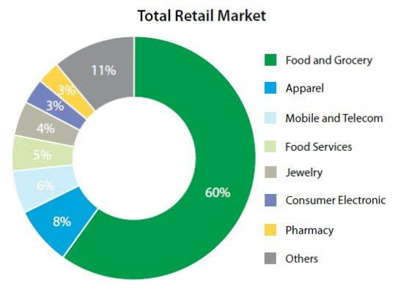

**Retailing formats in India**

* **Malls**: The largest form of organized retailing today. Located mainly in metro cities, in proximity to urban outskirts. Ranges from 60,000 sp.Ft.to 7,00,000 sq. ft. and above. They lend an ideal shopping experience with an amalgamation of product, service and entertainment; all under a common roof. Examples include Shoppers Stop, Pyramids, Pantaloons..
* **Specialty Stores**:

Chains such as the Bangalore based Kids Kemp, the Mumbai books retailer Crossword,RPG's Music World and the Times Group's music chain Planet M, are focusing on specific market segments and have established themselves strongly in their sectors.

* **Discount Stores**:

As the name suggests, discount stores or factory outlets, offer discounts on the MRP through selling in bulk reaching economies of scale or excess stock left over at the season. The product category can range from a variety of perishable/Non-perishable goods

* **Department Stores**:

Large stores ranging from 20000-50000 sq. ft, catering to a variety of consumer needs. Further classified into localized departments such as clothing, toys, home, groceries, etc.

* **Hypermarts/Supermarkets**:

Large self service outlets, catering to varied shopper needs are termed as Supermarkets. These are located in or near residential high streets. These stores today contribute to 30% of all food & grocery organized retail sales. Super Markets can further be classified in to mini supermarkets typically 1,000 sq. ft. to 2,000 sq. ft. and large supermarkets ranging from of 3,500 sqft to 5,000 sq. ft. having a strong focus on food & grocery and personal sales.examples Big Bazar, Reliance Hypermarts.

* **Convenience Stores**:These are relatively small stores 400-2,000 sq. feet located near residential areas. They stock a limited range of high-turnover convenience products and are usually open for extended

periods during the day, seven days a week. Prices are slightly higher due to the convenience premium.

* **MBO’s** :

Multi Brand outlets, also known as Category Killers, offer several brands across a single product category. These usually do well in busy market places and metros.

**Organizational structure:**

ZONAL MANAGER



CLUSTER MANAGER

AREA MANAGER

STORE MANAGER

ASSISTANT STORE MANAGER



SUPERVISOR COMMERCIAL ASSOCIATE

CUSTOMER SERVICE ASSOCIATE

**Indian retailers**

1. **Reliance Retail Limited:**

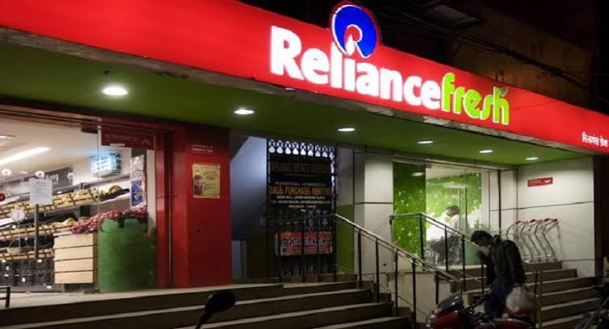

Corporate office – Mumbai, Maharashtra Establishment – 2006 .Business –Retail Website – www.ril.com .Reliance retail limited was incorporated in 2006, a part of Reliance industries. The company has been rated among the best retail companies in India. It offers complete

retail solutions such as food items, lifestyle, fashion, consumer electronics products, home decorative products etc. The company has a total of 1500 outlets in the country.

1. **Pantaloons Retail Limited:**

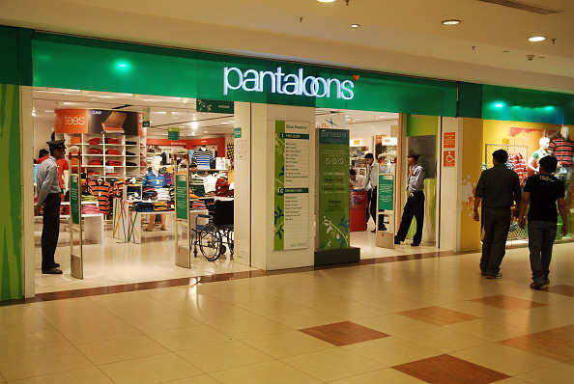

Corporate office – Mumbai, Maharashtra | Establishment – 1997 |

Business – Retail | Website – www.pantaloonsfashion.com |

It is a flagship company of Future group and one of the leading retail company in India. The company has more than 1000 outlets across the India and 35000 employees. Company‘s brands include Big Bazaar, food Bazaar Brand factory, Top 10 and Sitars.

1. 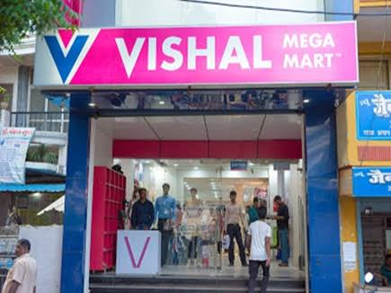**Vishal mega mart:**

Corporate office – Delhi | Establishment 1986(Kolkata)

Business – Manufacturing and Retail

**4.Aditya Birla Retail:**

Corporate office – Mumbai, Maharashtra | Establishment – 2006 |

Business – | Website – www.adityabirla.com |

Aditya Birla retail limited is a subsidiary of Aditya Birla group established in year 2006 which owns over 500 supermarkets and 15 hypermarkets. The company is rated as top 10 retail companies in India and received prestigious Master brand Award 2012 by World Brand congress in retail brand category.

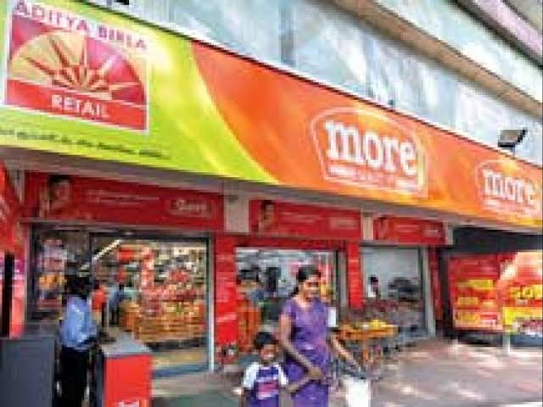

**Impact of covid-19 on retail industry**

The sudden impact of COVID-19 has sent shockwaves across businesses and the economic order. Now, more than ever before, retail businesses have a crucial role to play in protecting employee and customer health, in developing practical solutions that will shape the recovery, and in bolstering a sagging economy. In addition to the need-based response on a war footing, what will help retailers serve customers better are nimble and pragmatic AI-enabled interventions such as staff rescheduling and deployment time and demand transferability to identify substitutes of essential products. Plug-and-play solutions can ease the pain of managing some of the foundational yet critical activities during these stressful times. Given the volatile impact unleashed by the pandemic, it is clear that organizations and individuals need to gear up for a period of uncertainty. While pursuing economic behaviours aligned with Business 4.0TM—leveraging ecosystems, personalizing at scale, embracing risk, and creating exponential value—might pivot businesses towards growth, transformation, and sustainability, we believe enterprises also need to be purpose-driven, resilient, and

adaptable. Using this opportunity to build resilience and adaptability around the purpose they are setting out to meet will leave them stronger, not just now but also in post COVID-19 times.

**Covid- 19 impact on Consumer behavior**

While the world comes together to flatten the curve in the fight against coronavirus, retail gets polarized into ‘essential’ and ‘non-essential’, forcing customers to take a hard look at what is in their basket. As the pandemic accelerates from one stage to the next, there is a distinct shift in customer behaviours—from making conscious choices to preserve health, to stock-piling of essentials and deferring aspirational purchases, to embracing ‘safe’ shopping .

Emerging Behavior and Patterns

Phase1

Prepare in Anticipation

Consumers focus more on improving resistance, and building strength and immunity.

Phase 2

Advent of pandemic

Consumers resort to panic-driven stock piling of essentials, with reduced spend on discretionary items .

Phase 3

Lockdown/Quarantine

Consumers increasingly shop online for essentials to comply with government directives (e.g., social distancing)

Phase 4

Return to normal

Consumers buy essentials and get back to discretionary spending.

This sudden change in customer behavior—prioritizing needs over wants—has skewed demand patterns of product categories leaving retailers in a tizzy. While the sizable dip in demand for product lines such as apparel is likely even out as people get back to regular consumption patterns, fashion houses who could not launch their spring or summer collections may potentially be left with piles of unsold inventory. Responding effectively and ensuring that recovery is less painful, requires a segment-specific approach.

**SURVEY RESULTS**

This will be weak even after the lockdown is lifted as the consumers will be in buying mode but only what is needed. India’s retail industry would take at least 6-9 months to recover from the impact of the COVID-19 pandemic. 20-25% of industry players may need a capital infusion to stay afloat and about 20% of jobs in the industry may get impacted. At present, 7-8% working retailers are of essential commodities retailers.

The situation will be weak even after the lockdown is lifted as the consumers will be in buying mode but only what is needed. After that, we will have a recovery mode. The industry has more than 15 million retailers including big and small, traditional and modern trade. Retail employs 40-50 million Indians directly.

Fashion, furniture, electronics, luxury retailers and automobiles will be hit the hardest as consumers forego discretionary purchases in favour of stocking up on food and household supplies. Grocers win, will come at a higher cost of operations and need to be better prepared for the Omni channel shopper and responsiveness to demand shifts.

Retail technology investments will continue to reflect digital transformation efforts, as retailers reserve capital for technology investments by reducing spending on store openings and remodels.

Cash rotation would slow down for all categories retailers except food, grocery, pharma stores who would be less impacted as they have covered substantial sales target in March itself. Large retail and real estate can be impacted as they would expect recognition in rental contracts. Supply chain which has always been an important factor in retail shall be the biggest challenge and would require realignment. As retail engages high manpower, getting back manpower would also be a challenge post lockdown and hence it would also impact retail experience and customer service.

The online retailers would be highly active for essential goods and hence portal up-gradation would also be a challenge to consider due to the number of customers shopping online. Hence there could also be a hike by 5-7% in online purchase for a year. However, the e-commerce sector will also face the challenges and will see a dip in growth for other commodities. There will be high pressure on the supply chain for deliveries of products and another challenge would be to equip their employees with appropriate resources to manage the operations with no disruptions. The extent of the outbreak and lockdown would directly impact the length of the recovery cycle. The lockdown implemented by the Government to prevent the spread of COVID-19 in the country has greatly affected the retail business. Most stores, except stores selling Essential Food & Grocery, have been shut across the country. Garments, Saris, Electronics, Mobile Phones, Furniture, Hardware, etc. almost all stores are closed. Non-Grocery/Food Retailers are reporting 80% to 100% reduction in sales. Even retailers of essential items are facing losses as they aren’t allowed to sell non-essential items, which would bring them higher margins.85% of the retail costs are fixed costs, which is putting several financial pressures on retailers. The industry is experiencing severe liquidity challenges, which can lead to large scale unemployment. The cash inflow of the industry has come to a standstill, while the fixed operating costs remain intact, as per the survey conducted by Retailers Association of India .

**Impact on Non-Food Retailers** –More than 95% of Non-Food Retailers has their shops closed in the lockdown and are looking at practically no revenues till the lockdown is in place. In the next 6 months Non-Food Retailers expect to earn 40% as compared to last year’s revenues.

**Impact on Food Retailers** – Most of Food Retailers also sell non-essential goods in the same and / or different stores. The non-food business in the stores has come to a standstill in the lockdown leading to revenue loss. Additionally, 25% of these retailers have non-food stores that have been closed leading to further losses. In the next 6 months, Food Retailers expect to earn 56% as compared to last year’s revenues.

**Overall Business Outlook** – 70% of retailers expect the business recovery to happen in more than 6 months, 20% expect it to take more than a year.· <10% of Medium and Large Retailers expect to earn any profits till Aug’20, 26% of Small Retailers expect to earn profits in the same time period.

**Manpower rationalization** – Small Retailers are expecting to lay-off 30% of their manpower going forward, this number falls to 12% for Medium Retailers and 5% for Large Retailers. On the whole, retailers who responded to the survey expect a layoff of about 20% of their manpower.

**New product idea generation**

**Internal Sources:**

The unbeatable source of idea generation starts from internal sources. Many companies are paying incentives to their employees to come up with workable ideas.

**Market Research:**

Companies are constantly keeping an eye on the volatile market to review the changing needs, requirements and trends that are loved by all.

**Rivals:** Company’s SWOT analysis can help you with ideation. Take a look at the offering at your rivals and find vulnerabilities and cons before strategizing your idea.

**SWOT analysis:**

Business organizations may require their weakness, strengths, opportunities and threats to come up with a feasible idea.

**Consumers:**

 Interviewing your consumers will definitely help you to generate best ideas. You can conduct various review sessions and polls in order to come up with the best.

**SCAMPER Tool for idea generation**

SCAMPER refers to a thought spankers Or provocations which help you to innovate on an existing products, service or situation by looking thorough different lenses. There are seven Provocation lenses in the SCAMPER method-

* **S-**Substitute
* **c-**Combine
* **A-**Adapt
* **M-**Modify
* **P-**Put to another use
* **E-**Eliminate
* **R-**Reverse

**List of ideas**

1. Due to covid19 situation the offine store use online platform for selling their product .
2. Online platform include the demo videos and describe about all details about the produt for user understanding.
3. Use CRM software for customers solve query about the produt and give details how they purchase the produt without going the store.
4. The packaging should highly productive and the delivery boy is maintaining hygienic during the produt delivery .
5. The retail store give assurance to the customers about the hygienic and the sanitation process through a short video.
6. The store should give a sanitizer free when the customers buy products from their shop.
7. In side the store social distancing should maintain properly.
8. In social media sites Advertise our store. create and analyse the target group for their necessary produt.
9. Create application users friendly and Advertise.
10. Now people mind has changed . They don’t like polluted food due to covid. They focus the hygienic food and cleanliness. So we maintain that.
11. Now online retailing is highly demand according the survey for the pandemic Pandemic situation in the country.
12. Adapt live stream shopping.
13. Google local inventory ADS can Advertise nearby available products That can be delivered by bike courier.
14. Create own shopping channel through Instagram.
15. Good consulting, personal touch and creation of trust and loyalty becoming essential success factor due the covid19.

**RESEARCH METHODOLOGY**

The study is an analytical and descriptive one. The data is collected solely from primary sources i.e. by doing a survey among a selected group of people and we have also referred secondary sources i.e.refered print journals, online journals, books, reports etc.

**Sample Design**

A sample design is the framework, or road map, that serves as the basis for the selection of a survey sample and affects many other important aspects of a survey as well. We have used Non-probability sampling technique. It is a technique where the samples are gathered in a process that does not give all the individuals in the population equal chances of being selected.

**Sample Size :**

Sample size is the number of observations in a sample. The survey has been conducted in Madurai city with 30 customers as Respondents.

**Sample Area**:

The total area under investigation is divided into small sub-areas which are sampled at random or by some restricted random process. We have collected sample in and around by-pass road Bhubaneswar.

**Sources of Data**

We have collected data from both the primary source as well as the secondary source i.e, by searching through Internet.

**Primary Source-**

The primary data was collected by means of a survey. questionnaires were prepared and customers of the Retail industry at were approached to fill up the questionnaires. The questionnaire contains15 questions which reflect on the type andquality of services provided by the Retail industry to the customers. The response o f thecustomer is recorded on a grade scale of stronglydisagree, disagree, uncertain, agree and stronglyagree for some questions. The filled upinformation was later analyzed to obtain therequired interpretation and the findings.

**Secondary Source**-

In order to have a proper understanding of the customer service of Retail industry a depth study was done from the various sources such as books, a lot of data is also collected from the official websites of the Retail industry and the articles from various search engines like Google, yahoo search and answers.com.

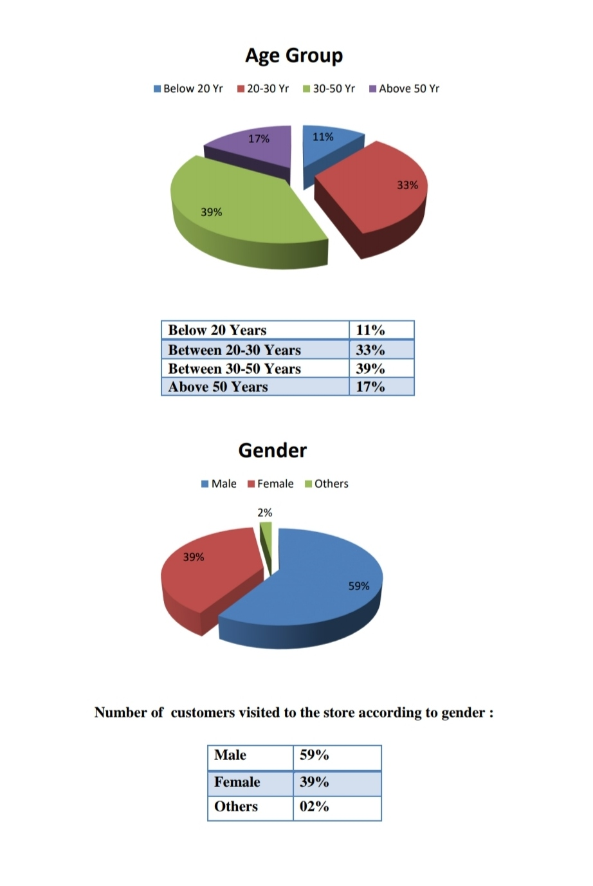**Data Interpretation analysis**

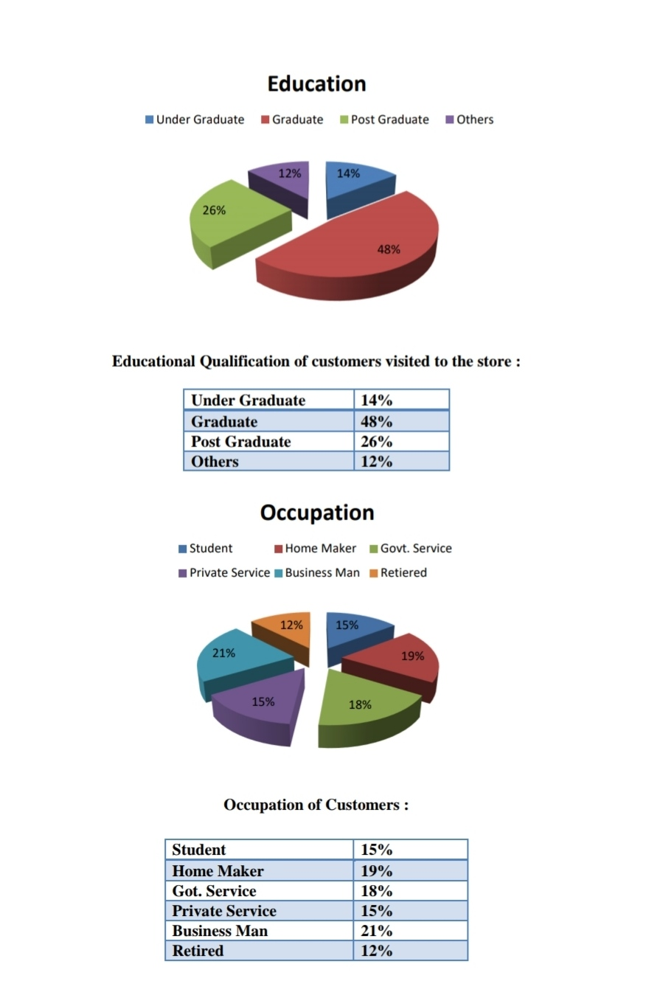

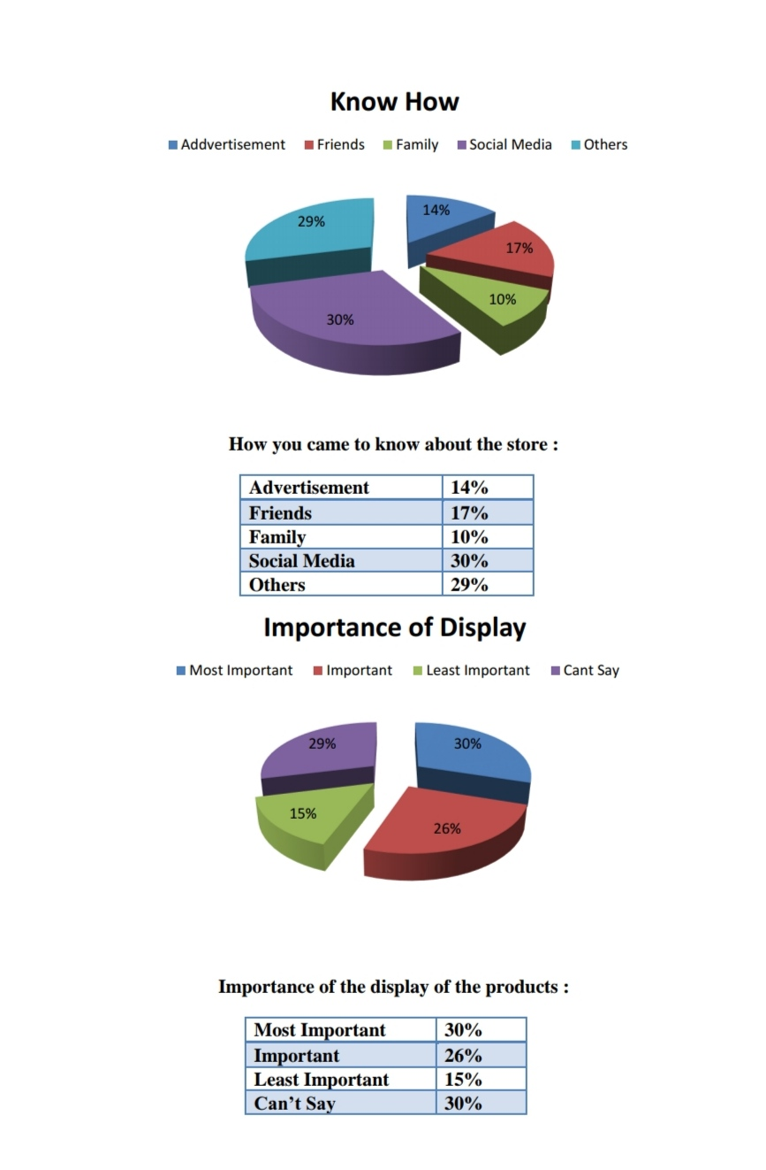

**Conclusion**

From the study we conclude that all the customers are not fully satisfied with the retail industry but also with the remaining competitors. Customers are finding some faults with every apparel stores. The customers entering into the store are happy with the offers available in the store that the offers are good value for their money. But from my observation i can conclude that retail industry was spending lot of money for different types of marketing and promotional activities for driving more customers into the stores, but retail industry was not concentrating on converting the people who entered the store into a final customers.After conducting a thorough survey and research on Reliance Trends it is observed that it has been perceived as a good brand. It has good customer loyalty and also attracts a large number of new customers. It also offers its customer a unique shopping experience a few brands can offer. It also got an advantage of its locations situated in commercial locations. There are a good number of Reliance Trends stores located across the city which makes it easy for customers to access the store. Customers seemed to be happy when it came to the layout of the store, the merchandise, and cleanliness of the store, ambience, etc. Consumers have high expectations from Reliance Trends regarding pricing. They expect good collection of clothes at much cheaper price. The future for Reliance Trends indeed seems to be bright and it should continue to do well as seems apparent from the response of the customers.

**QUESTIONNAIRE**

Hi! Hope you enjoyed the shopping. It would be really great if you can help me (MBA Student of CIME, Bhubaneswar) in understanding a few things that would make shopping effective and entertaining. Please help me by filling out this questionnaire and be a part of my Marketing Research project.

Name of the Store: Reliance Fresh, pantaloons, big bazaar

Location: Bhubaneswar

1. Will digital marketing go through big changes after this period covid 19 finishes?

Ans-Yes/ No

1. Online home delivery should implication in retail industry?

Ans-Yes /No

1. In the store sanitation should implement or not?

Ans-Yes /No

1. Inside the mall social distance should maintain or not?

Ans-Yes /No

1. how many people should go inside the store at a time?

Ans - ____________

1. Offers or discounts are implimated after covid 19?

Ans-Yes /No

1. New product should innovate after covid 19?

Ans-Yes /No

1. Which type of produt should introduce after covid 19?

Ans- ____________

1. New idea should implement on retail industry after covid 19?

Ans-Yes / No

1. What the customers prefer In retail market go online or offine?

Ans- _______________

1. The staffs are very friendly or not?

Ans-Yes / No

1. The price of the produt in the store are alright or not?

Ans- Yes /No

1. Covi19 guideline should implimated in store?

Ans – Yes /No

1. Which type of produt should demand after covid19?

Ans- ______________

1. Are you satisfied ?

Ans- Yes /No

1.Name- _________________

2. Gender: Male / Female

3. Age: 10-20 / 20-30 / 30-40 / 40-50 /50 & above

4. Education: _______________

5. Occupation: Student/ Employee /Business /any other (please specify)

6. Contact- ______________

**BIBILOGRAPHY**

<https://en.m.wikipedia.org/wiki/Retailing_in_India#:~:text=Retailing%20in%20India%20is%20one,the%20world%20by%20economic%20value>.

<https://www.braineet.com/blog/co-creation-examples/>

<https://hbr.org/2002/01/turn-customer-input-into-innovation>

<https://www.growthbusiness.co.uk/include-consumer-input-every-stage-product-development-2553520/>

<https://www2.deloitte.com/ca/en/pages/consumer-business/articles/consumer-driven-innovation.html>